**911 Calls Data Analysis**

Using data analysis with Python on 911 Call Data sourced from Kaggle.

**Findings**

* Top 5 zip codes for 911 Calls
  1. 19401
  2. 19464
  3. 19403
  4. 19446
  5. 19406
* Top 5 townships for 911 Calls
  1. Lower Merion
  2. Abington
  3. Norristown
  4. Upper Merion
  5. Cheltenham
* Type of reasons for 911 calls and their respective counts

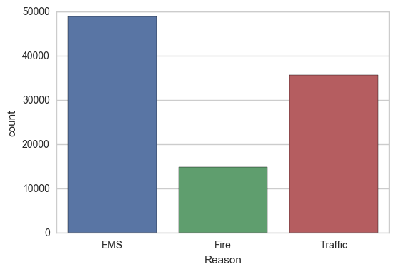

* 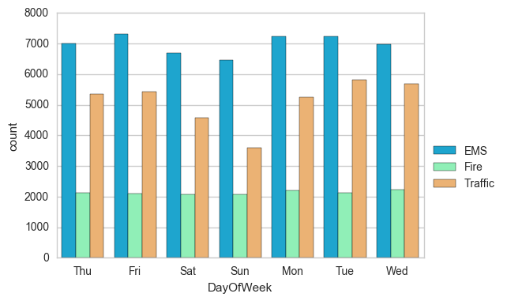Separating reasons by days of the week, as well as their respective counts
* Total number of 911 Calls per month

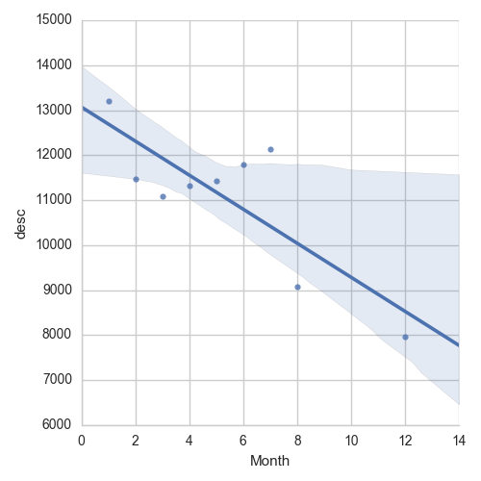

* Grouping aggregate calls by month to see fluctuations throughout time

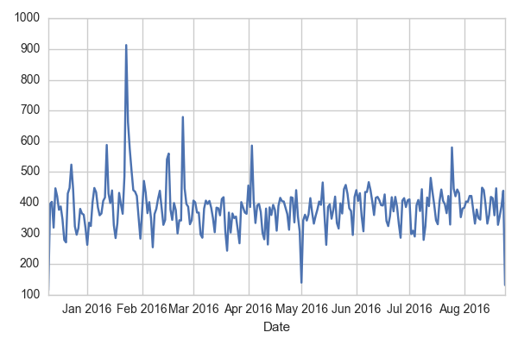

* Separating 911 calls by reason (EMS, Fire, and Traffic)

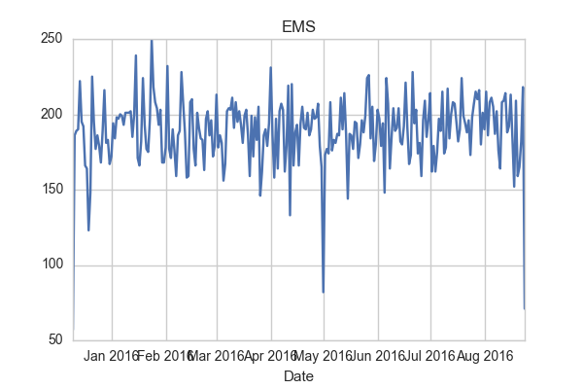





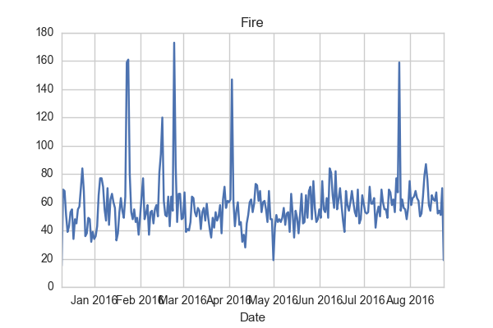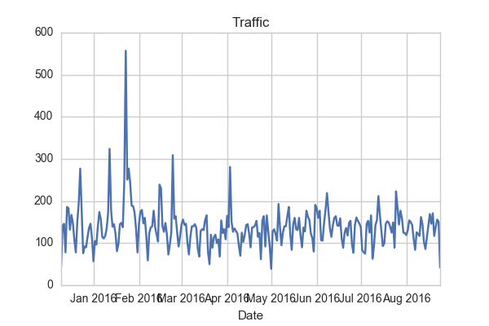

* Heat Map and Cluster Map showing 911 Call Activity per hour each day of the week

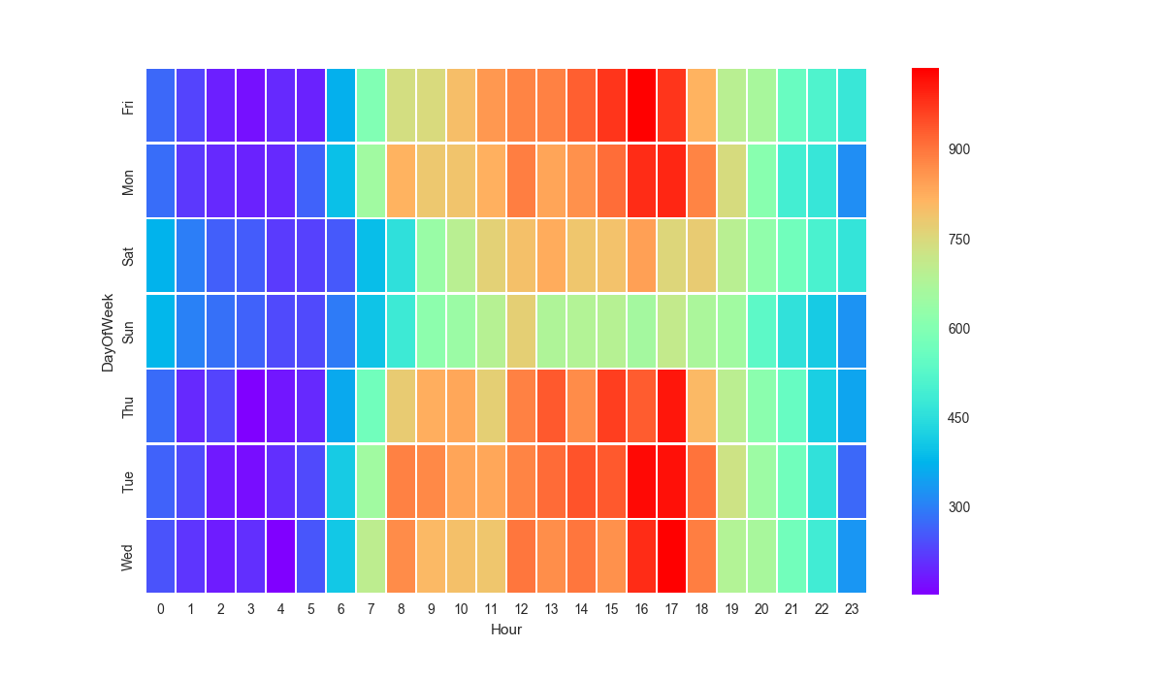

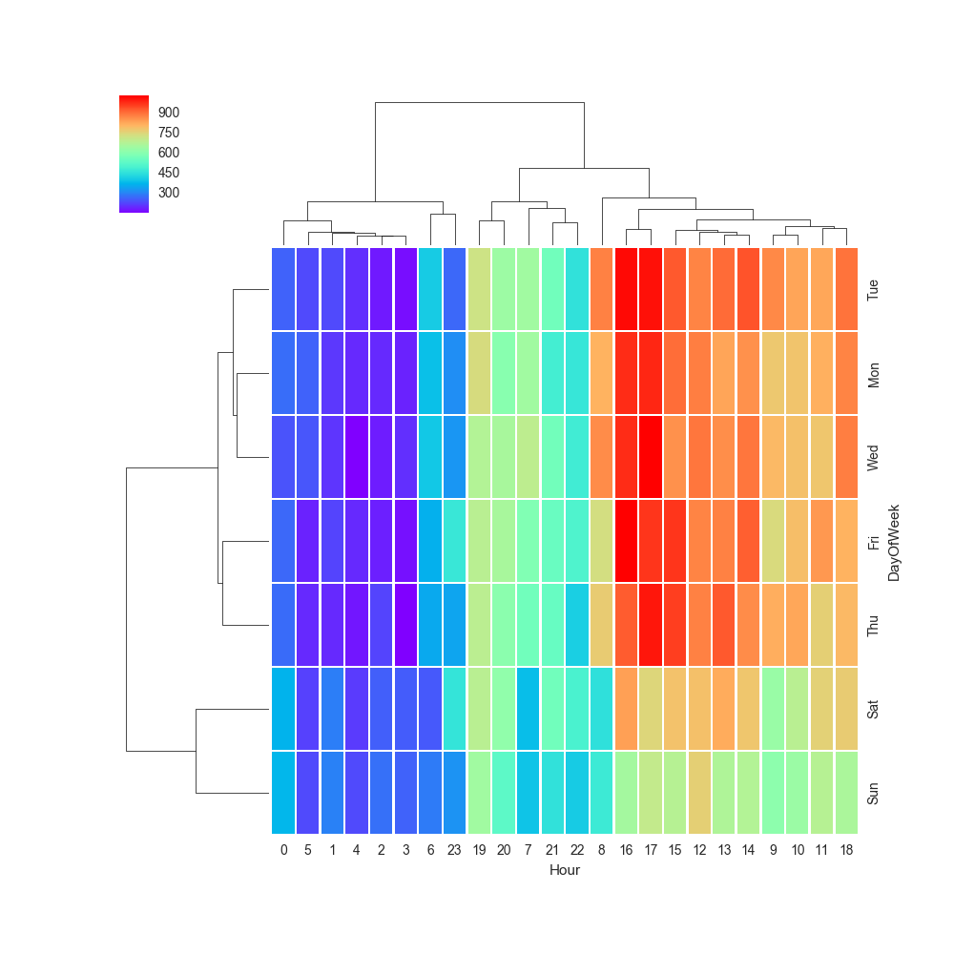

* 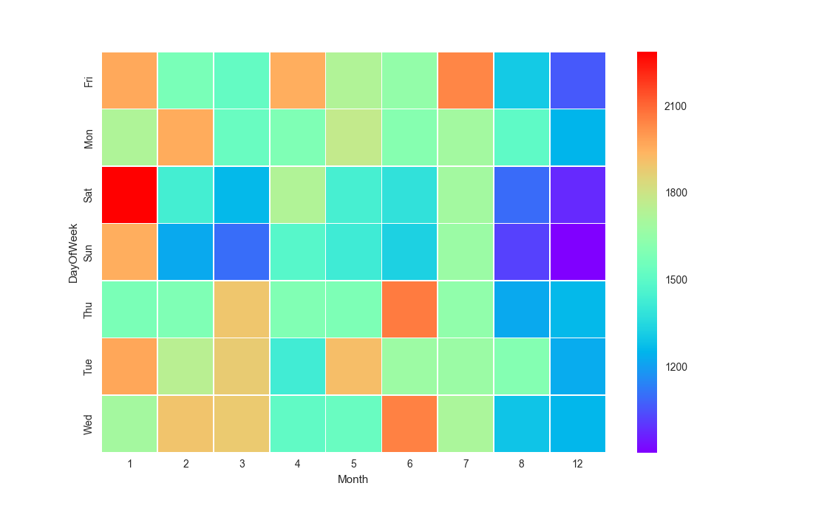Heat Map and Cluster Map comparing day of the week against the month

